38.65: a) Quantization of angular momentum implies 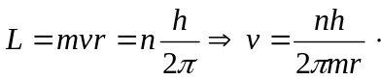
But
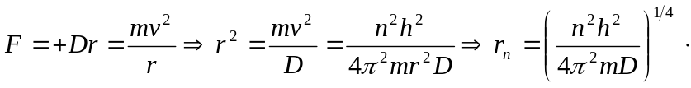
b) The energy 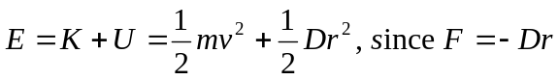 is completely analogous to
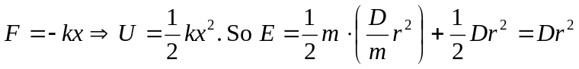
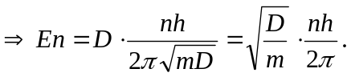
c) Photon energies 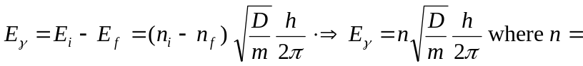
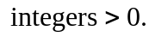
d) This could describe a charged mass attached to a spring, being spun in a circle.

